**CSE523 Machine Learning**

**Prof. Mehul Raval**

**Anomaly detection in computer networks to identify unusual activity or potential security threats**

**Week 2 Report**

| **Name** | **Enrolment Number** |
| --- | --- |
| Vatsal Patel | AU2040043 |
| Shreya Karia | AU2040076 |
| Digant Patel | AU2040086 |
| Samarth Chauhan | AU2040097 |

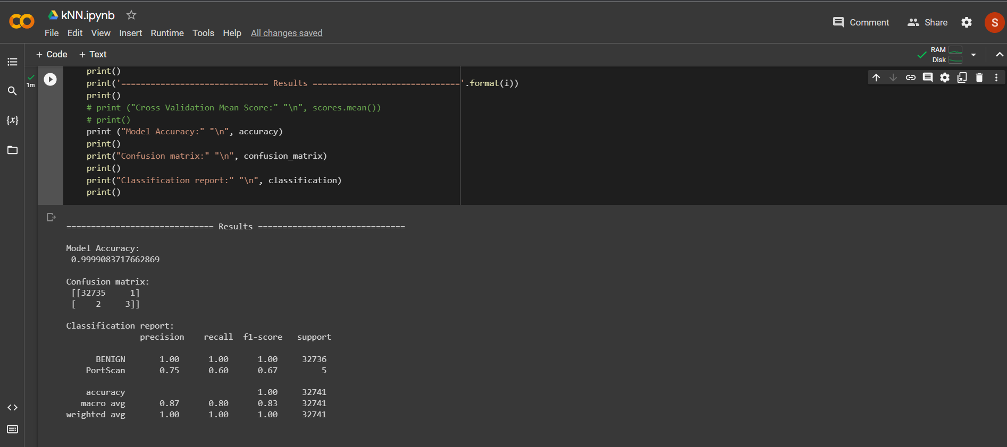

<https://colab.research.google.com/drive/1VQj6fodMmLFpGpWf3SJ1rN6-cLiwem_N#scrollTo=iVblpWRJLiYY>

We tried to implement the KNN algorithm. The code and its output can be seen in the link provided. It takes a lot of time to execute and google collab even crashed several times. Next week we are planning to try a better and more efficient algorithm.